APPENDIX 2
EXECUTION OF REFERENCE LISTS TRANSLITERATED INTO LATIN ALPHABET (REFERENCES)
(Refers to sources in all languages that use Cyrillic (Russian, Ukrainian, etc.)
The list should begin with the heading References.
The title of the source should necessarily be in italics.
The list of references in Latin (References) is made separately from the list of references in Russian, together with the other part in English, placed after the article. It is not allowed to mix Russian and English parts in one reference item, as well as to cut short the Russian list of references by means of transferring all the English items to the English-language References. Foreign sources that use the Latin alphabet (English, German, French, etc.) need to be repeated in both reference lists (in References - without translation into English, and without specifying the language of the source).

The form of bibliographic description of the Russian sources in the English-language References:

Description of the Articles from the Russian Journals.
Full description:
• Authors (transliteration).
• Article title (transliteration)
• [Translation into English of the article title (in square brackets, as the English title is not the main)].
• Title of the journal (transliteration in italics) – title of the journal in English (if there exists an officially registered one),
• year, volume (vol.), number (no.), pages (pp.)
• indication of the language of the article (in Russian) after the description of the article.

Examples:
Krymov S. M., Kushnirenko T. V. Opisaniye investitsiy v cheloveka na baze kontseptsiy zhyznennogo tsikla [Description of investments into the man on the basis of the life cycle conception]. Vestnik Tomskogo gosudarstvennogo pedagogicheskogo universiteta - TSPU Bulletin, 2007, no. 9 (72), pp. 38-39 (in Russian).
Yastrebova L. N. Rol' pervogo inostrannogo yazyka v obuchenii angliyskomu yazyku kak vtoroy spetsial'nosti [The Role of the First Foreign Language in Teaching English as a Second Pedagogical Specialty]. Izvestiya Samarskogo nauchnogo tsentra RAN - Izvestiya Samara Scientific Center of RAS, 2013, vol. 15, no. 2 (3), pp. 660-666 (in Russian).
Belonogov R. N., Titova N. M., Dykhno Yu. A., Lapeshin P. V., Kudryashov E. V., Savchenko A. A. Okislitel’naya modifikatsiya belkov i lipidov plazmy krovi bol’nykh rakom krovi [Oxidative modification of proteins and lipids of blood plasma of patients with lung cancer]. Sibirskiy onkologicheskiy zhurnal - Siberian Journal of Oncology, 2009, no. 4, rp. 48-51 (in Russian).
If the source has DOI, it should be provided (after the recording).

Description of the Article with DOI.
Zang Z., Zhu D. Experimental research on the localized electrochemical micro-machining. Russian Journal of Electrochemistry, 2008, vol. 44, no. 8, pp. 926-930. DOI: 10.1134 / S1023193508080077.

Description of the Article from Electronic Journal.
• Authors (transliteration).
• [Translation into English of the title of the article].
• Title of the journal (transliteration in italics) – title of the magazine in English (if there exists an officially registered one),
• year, volume (vol.), number (the no.), pages (pp.).
• indication of the language of the article (in Russian) after the description of the article.
• Access mode (Available at or URL): http: // www ... (date of appeal (accessed).

Example (without transliteration of the name of the article):
Sidorov S. V. [Innovation in development of rural school in Russia of the second half XVIII - the beginning of the XX century. Information humanitarian portal "Knowledge. Understanding. Ability "]. Pedagogika. Psykhologiya - Pedagogy and Psychology, 2010, no. 2 (in Russian). URL: http://www.zpu-journal.ru/e-zpu/2010/2/Sidorov_Innovations/ (accessed 25 June 2010).

Description of the Conference Proceedings.
• Authors (transliteration).
• Article title (transliteration)
• [Translation into English of the article title].
• Title of the conference (transliteration in italics)
• [Translation into English of the title of the conference].
• Place of publication (city) in English (Moscow, St. Petersburg, Rostov-on-Don),
• year. Pages (pp.).
· indication of the language of the publication (in Russian).

Example:
Filonov N. G., Kovalenko L. V. Logisticheskiy analiz struktury sovokupnykh izderzhek pri formirovanii potokov poleznykh resursov [Logistic analysis of the structure of cumulative expenses in forming the useful resources flow]. Materialy mezhregionalnoy nauchno-praktichskoy konferentsii (VI Yuzhno-Rossiyskiy Logisticheskiy forum “Aktualnye problemy i perspektivy razvitiya regionalnoy logisticheskoy infrastruktury” [Materials of the Interregional Scientific and Practical Conference (VI South-Russian Logistics Forum "Current problems and prospects of development of regional logistics infrastructure")]. Rostov-on-Don, RGEU “RINH” South-Russian Association of Logistics Publ., 2009. Pp. 189–197 (in Russian).
It is possible to omit transliteration of the article title, providing only its translation in square brackets (however the transliteration of the conference title is required):
Filonov N. G., Kovalenko L. V. [Logistic analysis of the structure of cumulative expenses in forming the useful resources flow]. Materialy mezhregionalnoy nauchno-praktichskoy konferentsii (VI Yuzhno-Rossiyskiy Logisticheskiy forum “Aktualnye problemy i perspektivy razvitiya regionalnoy logisticheskoy infrastruktury” [Materials of the Interregional Scientific and Practical Conference (VI South-Russian Logistics Forum "Current problems and prospects of development of regional logistics infrastructure")]. Rostov-on-Don, RGEU “RINH” South-Russian Association of Logistics Publ., 2009. Pp. 189–197 (in Russian).

Description of the Book (Monograph, Collection).
• Authors (transliteration).
• Title of the monograph (transliteration in italics)
• [Translation into English of the title of the book].
• Place of publication (city) in English,
• Publisher (transliteration with addition Publ.), year.
• Total number of pages in the publication (the pages to which reference is made are indicated in the text - [5, c 132.], etc.).
• indication of the language of publication (in Russian).

Example:
Sadokhin A. P. Etnologiya: uchebnik [Ethnology: textbook]. Moscow, Gardariki Publ., 2000. 256 p. (in Russian).

Description of Translated Books.
• Authors (in the original spelling).
• Title of the original (in italics),
• Publisher’s imprint of the original: place of publication, publisher, year. Number of pages.
• In brackets after the words Russ. ed .: transliteration of the Russian translation of the title of the book (including the transliteration of surnames), imprint of the Russian-language edition: place of publication (city) in English, publisher (transliteration with addition Publ), year. Total number of pages in the publication.
Example:
Siebert H. Der Kobra-Effekt: Wie man Irrwege der Wirtschaftspolitik vermeidet. Deutsche Verlags-Anstalt (DVA), Stuttgart, 2001. 292 p. (Russ ed.: Zibert K. H. Effekt kobry:. Kak izbezhat’ zabluzhdeniy v politike: per s nem. Moscow, Novoye izdatel'stvo Publ, 2005. 239 p.).

Description of Dissertation or Abstract of Dissertation.
• Author (transliteration).
• Title (transliteration italics)
• [Translation of the title into English].
• Place of publication (city) in English,
• year.
• Total number of pages.
• indication of the language of publication (in Russian).

Example:
For abstracts: Goryunov V. V. Suverinitet Rossiyskoy Federatsii: sushchnost ', soderzhaniye, garantii. Avtoref. dis. kand. yurid. nauk [Sovereignty of the Russian Federation: essence, contents, guarantees. Abstract of thesis cand. of leg. sci.]. Ekaterinburg, 2007. 24 p. (in Russian).
For dissertations: Pozdeeva S. I. Kontseptsiya razvitiya otkrytogo sovmestnogo deystviya pedagoga i rebyonka v nachal'noy shkole.. Dis. dokt. ped. nauk [Concept of development of open joint action of a teacher and a child in primary school. Diss. doct. of ped. sci.]. Tomsk, 2015. 393 p. (in Russian).

For transliteration use BGN system (Board of Geographic Names).

Transliteration of Cyrillic - BGN/PCGN standard

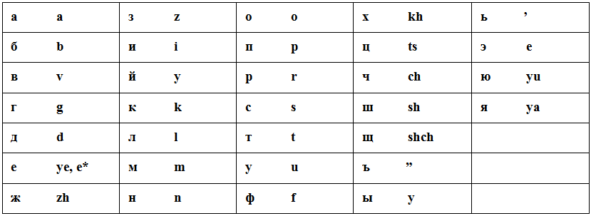
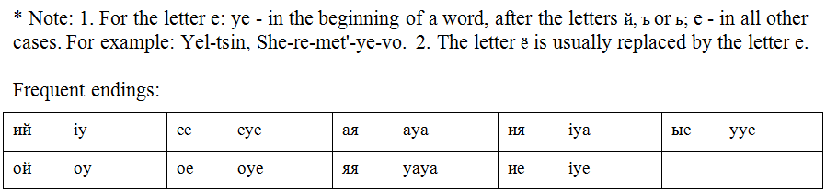

See BGN / PCGN standard at: http://transliteration.eki.ee/pdf/Russian.pdf

Transliteration is better to be done in special programs, not "manually" (as it is a laborious and time consuming process). In the previous edition of training manual (for 2012), it is recommended to use a special program (free) at the site http://www.translit.ru
Enter the program translit.ru, select the version of the transliteration standard, for example, mentioned above BGN, insert in the appropriate field the whole text of the References in Russian and chose «в транслит» ("in transliteration").

